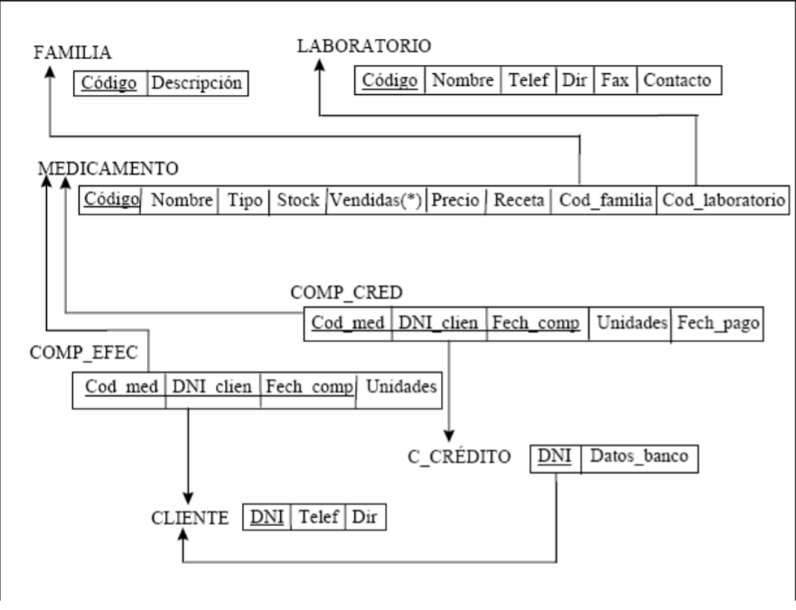

CREATE TABLE Familia(Codigo int PRIMARY KEY,

Descripcion varchar(300) NOT NULL);

CREATE TABLE Laboratorio(Codigo int PRIMARY KEY,

Nombre varchar(40) NOT NULL,

Telef char(9) NOT NULL,

Dir varchar(200) NOT NULL,

Fax varchar(9),

Contacto varchar(9) NOT NULL);

CREATE TABLE Cliente(DNI varchar(9) PRIMARY KEY,

Telef char(9) NOT NULL,

Dir varchar(200) NOT NULL);

CREATE TABLE C_Credito(DNI varchar(9) PRIMARY KEY,

Datos_banco varchar(200) NOT NULL);

CREATE TABLE Medicamento(Codigo int PRIMARY KEY,

Nombre varchar(40) NOT NULL,

Tipo varchar(20) NOT NULL,

Stock char(1) NOT NULL,

Vendidas int NOT NULL,

Precio int NOT NULL,

Receta varchar(700) NOT NULL,

Cod_familia int,

Cod_laboratorio int,

CONSTRAINT cod_fam_medicamento_fk FOREIGN KEY (Cod_familia) REFERENCES Familia(Codigo),

CONSTRAINT cod_lab_meidcamento_fk FOREIGN KEY (Cod_laboratorio) REFERENCES Laboratorio(Codigo));

CREATE TABLE Comp_Cred(Cod_med int NOT NULL,

DNI_clien varchar(9) NOT NULL,

Fech_comp date NOT NULL,

Unidades int NOT NULL,

Fech_pago date,

CONSTRAINT cod_med_comp_cred_fk FOREIGN KEY (Cod_med) REFERENCES Medicamento(Codigo),

CONSTRAINT dni_clien_comp_cred_fk FOREIGN KEY (DNI_clien) REFERENCES C_Credito(DNI),

CONSTRAINT comp_cred_pk PRIMARY KEY (Cod_med, DNI_clien, Fech_comp));

CREATE TABLE Comp_Efec(Cod_med int NOT NULL,

DNI_clien varchar(9) NOT NULL,

Fech_comp date NOT NULL,

Unidades int NOT NULL,

CONSTRAINT cod_med_comp_efec_fk FOREIGN KEY (Cod_med) REFERENCES Medicamento(Codigo),

CONSTRAINT dni_clien_comp_efec_fk FOREIGN KEY (DNI_clien) REFERENCES Cliente(DNI),

CONSTRAINT comp_efec_pk PRIMARY KEY (Cod_med, DNI_clien, Fech_comp));